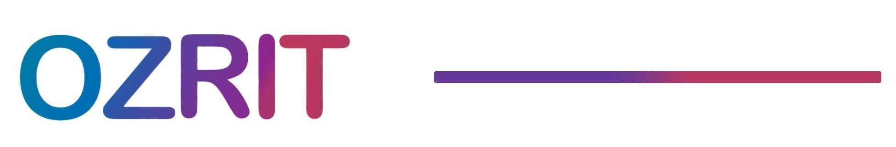

**Employment Termination – Unsatisfactory Performance**

Date :01.09.2025

Dear Employee   
  
This is to formally inform you that your employment with **Ozrit** is being terminated effective   
immediately due to consistently unsatisfactory performance.  
  
Despite repeated feedback, performance reviews, and opportunities for improvement, your   
work has not met the standards expected for your role. This demonstrates a gap between the responsibilities assigned and the results delivered, leading to this decision after a thorough   
review process.  
  
Your final settlement and any dues will be processed in accordance with company policy.   
Kindly ensure that all company property in your possession is returned at the earliest   
  
If you have any questions regarding this process, please feel free to reach out to the us.  
  
We thank you for your efforts during your tenure with us and wish you success in your   
future endeavors.

Regards

Vivekanand Reddy  
COO